# TCES 455, Autumn 2016

**Laboratory 4: Arduino/MATLAB Simulink Lab**

Prior to lab:

* Download/install MATLAB/Simulink Arduino IO package.

<http://ctms.engin.umich.edu/CTMS/index.php?aux=Activities_IOpack>

* Review and have a good understanding on
* 1st order and 2nd order systems step response performance specs
* PID controller
* Root locus

The purpose of this lab is to

* Enhance the understanding of system poles and zero(s) and their effects on system performance.
* Gain experience in designing controllers using algebraic pole placement and root locus.
* Implement a controller via analog circuit components, thereby avoiding the necessity of a microcontroller for achieving closed-loop control.

In this lab, read this web page

<http://ctms.engin.umich.edu/CTMS/index.php?aux=Activities_RCcircuitC>, and complete the following:

* Build the same circuit as described in the article i.e. $R=10kΩ$ and $C=100μF$.
* Design a controller using algebraic pole placement by following the process described in the article. Understand the effects of systems zeros.
* Implement the controller using analog circuit components. Record the experimental result similar as below

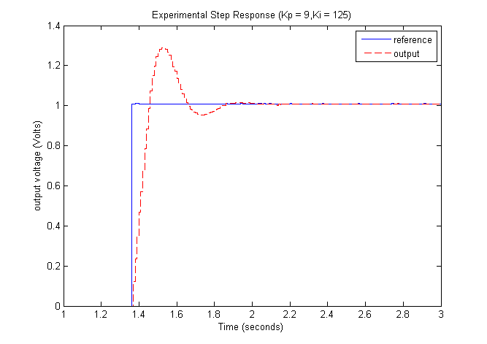

* Design the controller using root locus method. Repeat and record the experimental result similar as below

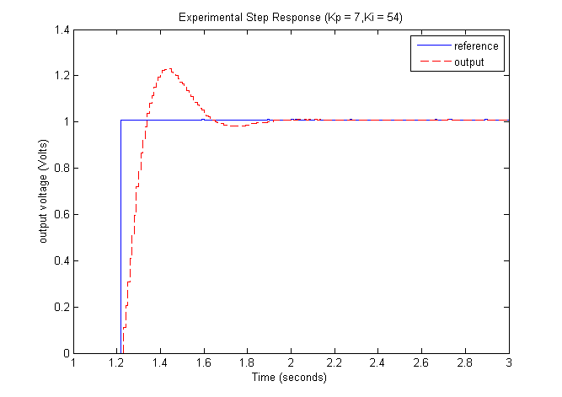

Make sure your notebook tracks everything you’ve done here and finish the one page summary by the due time.